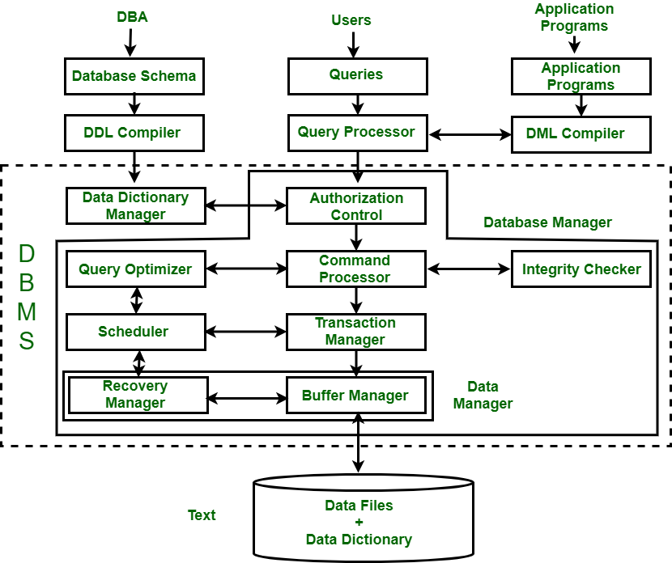

The database system is divided into three components:

Query Processor,

Storage Manager,

Disk Storage

**1. Query Processor :**   
It interprets the requests (queries) received from end user via an application program into instructions. It also executes the user request which is received from the DML compiler.   
Query Processor contains the following components – 

* **DML Compiler –**

 When the user inserts, deletes, updates or retrieves the record from the database, he will be sending requests which he understands by pressing some buttons

It processes the DML statements into low level instruction (machine language), so that they can be executed. 

* **DDL Interpreter –**

 Data Definition Language (DDL) is a query fired to create database, schema, tables, mappings, etc in the database. These are the commands used to create objects like tables, indexes in the database for the first time. In other words, they create the structure of the database.

It processes the DDL statements into a set of table containing meta data (data about data). 

* **Embedded DML Pre-compiler –**   
  It processes DML statements embedded in an application program into procedural calls.
* **Query Optimizer –**   
  It executes the instruction generated by DML Compiler.

**2. Storage Manager :**   
Storage Manager is a program that provides an interface between the data stored in the database and the queries received. It is also known as Database Control System. It maintains the consistency and integrity of the database by applying the constraints and executes the [DCL](https://www.geeksforgeeks.org/sql-ddl-dql-dml-dcl-tcl-commands/) statements. It is responsible for updating, storing, deleting, and retrieving data in the database.   
It contains the following components – 

* **Authorization Manager –**   
  It ensures role-based access control, i.e,. checks whether the particular person is privileged to perform the requested operation or not.
* **Integrity Manager –**   
  It checks the integrity constraints when the database is modified.
* **Transaction Manager –**   
  It controls concurrent access by performing the operations in a scheduled way that it receives the transaction. Thus, it ensures that the database remains in the consistent state before and after the execution of a transaction.
* **File Manager –**   
  It manages the file space and the data structure used to represent information in the database.
* **Buffer Manager –**   
  It is responsible for cache memory and the transfer of data between the secondary storage and main memory.

**3. Disk Storage :**   
It contains the following components – 

* **Data Files –**   
  It stores the data.
* **Data Dictionary –**   
  It contains the information about the structure of any database object. It is the repository of information that governs the metadata.
* **Indices –**   
  It provides faster retrieval of data item.

**What Data Dictionary consists of**

Data Dictionary consists of the following information −

* Name of the tables in the database
* Constraints of a table i.e. keys, relationships, etc.
* Columns of the tables that related to each other
* Owner of the table
* Last accessed information of the object
* Last updated information of the object.
* Details about all the tables in the database, such as their owners, their security constraints, when they were created etc.
* Physical information about the tables such as where they are stored and how.
* Table constraints such as primary key attributes, foreign key information etc.
* Information about the database views that are visible